 | 26.10 Editors - Properties Editor - Particle Properties Tab
Table of content
Introduction 2
Particle Modifier 2
Workflow 2
Header 3
List of Particle Systems 3
Realtime 3
Render 3
Drag Handler 3
Search Field 3
Invert 3
Sort by Name 3
Add Particle System Slot 4
Remove Particle System Slot 4
Particle Specials 4
Copy Active to Selected Objects 4
Copy All to Selected Objects 4
Convert to Curves 4
Duplicate Particle Systems 4
Remove all Particle Systems 4
Particle property 4
Particle settings browser 4
Edit Box 4
Fake User 4
New Particle Settings 5
Remove Particle Settings 5
Type 5
Emitter 5
Hair 5
Regrow 5
Advanced 5
Delete Edit 5
Disconnect Hair 5
Disconnect All 5

Introduction
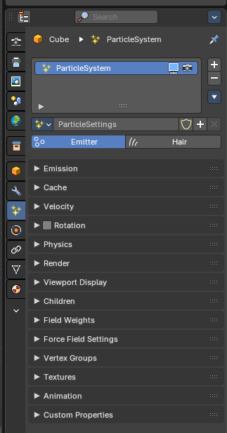
A particle system is used to animate lots of small objects at once. Particles. Each particle can be a point or a mesh, and can be joined or dynamic. They may react to different forces and influences. And they can have a life span.
There are two types of particles. Emitted particles and hair. Emitted particles are used for things like fire, smoke, mist and many other animated effects. Hair is used for hair effects, at characters for example. Some settings are the same for both types. These chapters are unioned. But each has also its own set of tools. These chapters are separated.
Particles uses a regular mesh object as the emitter. Other object types does not have the particle tab.

Particle Modifier
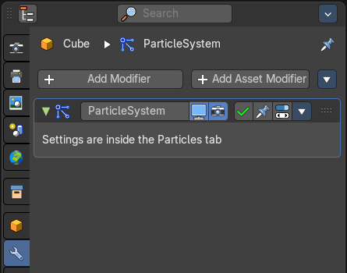
When you create a particle system then a particle modifier gets added in the Modifiers panel. This works also the other way around. You can also add a particle modifier in the modifier tab. The settings remains in the particles tab.

Workflow
Create a mesh.
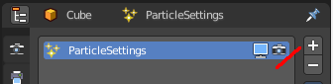
Create one or more Particle Systems to emit from the mesh.
Choose the particle system type. Emit or Hair.
Go through the particle settings to adjust the Particle System settings to achieve the desired effect.
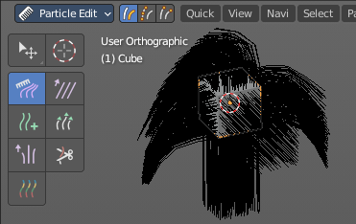
For Hair particle systems, switch to particle edit mode, and comb the emitter’s flow.
To see the effect for emitted particles press play.

Header

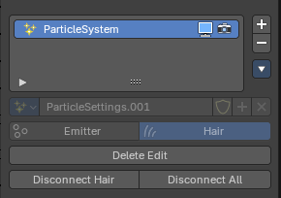
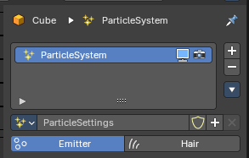
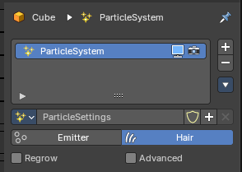

List of Particle Systems
A list of the particle systems for this object. Double clicking allows to rename it.

Realtime
Display the particle system in the viewport.

Render
Display the particle system in the rendered result.

Drag Handler
The two vertical lines at the end is a handler with which you can expand the list.

Search Field

You can expand a search field at the bottom of the list. Type in your term and hit enter to filter for your term.

Invert
Exclude the search term instead of searching for it.

Sort by Name
Sort the List by name.

Add Particle System Slot
Adds a new particle system.

Remove Particle System Slot
Remove the particle system.

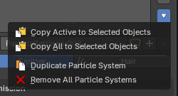
Particle Specials

Copy Active to Selected Objects
Copies the active particle system to all selected objects.

Copy All to Selected Objects
Copies all particle systems from the active object to all selected objects.

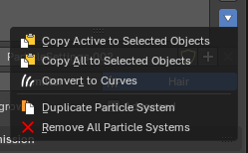
Convert to Curves
Hair mode only. Add a new curve object based of the current state of the particle system.

Duplicate Particle Systems
Duplicates the particle system within the active object. The Duplicate Settings option (in the Adjust Last Operation panel) will duplicate settings as well, so the new particle system uses its own settings.

Remove all Particle Systems
Removes all particle systems.

Particle property

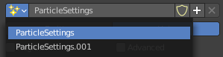
Particle settings browser
A particle settings browser with the available particle systems in the scene.

Edit Box
The name of the currently active palette. You can also rename the palette here. A click into the edit box makes the name editable.

Fake User
Fake User sets the element to have a fake user. Data without a user is normally not saved. But sometimes you want to force the data to be kept even when the data block has no user.

New Particle Settings
Add a new particle system.

Remove Particle Settings
Removes the particle system as the active particle system. Note that the particle system is still in the list.

Type

Main selector of the system type.

Note that some of the panels are identical for both particle types. But some not. Even when they have the same label.

Emitter
Emitter type. Particles are emitted from the object.

Hair
Hair type, rendered as strands.

Regrow
Type Hair. Regrows the hair for each frame. This is useful when you are animating properties.

Advanced
Type Hair. Enables advanced settings, and reveals some more functionality. Which reflect the same ones as working in Emitter mode.

Delete Edit
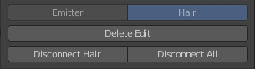
Appears when you modify the particles in particle edit mode. Resets the particle system to the default state before combing.

Disconnect Hair
Appears when you modify the particles in particle edit mode. Disconnect the selected hair from the emitter object.

Disconnect All
Appears when you modify the particles in particle edit mode. Disconnect the whole hair from the emitter object.

